VidyaLekha Help Portal and Help desk Ticketing System
We have integrated Freshdesk as Customer help Portal and Support Ticketing system in Vidyalekha.
We have sent invitation to all of you on your gmail ids to join Vidyalekha.freshdesk.com. Let me know if anyone has not received it.
Henceforth all support tickets will be logged in to this system including sales team. You can login through web or freshdesk Mobile App.
Explained login process and ticket raising process as below.
- Web login: https://vidyalekha.freshdesk.com
Click on LOGIN
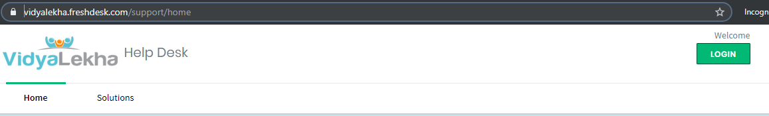
Then Click on Agent Login
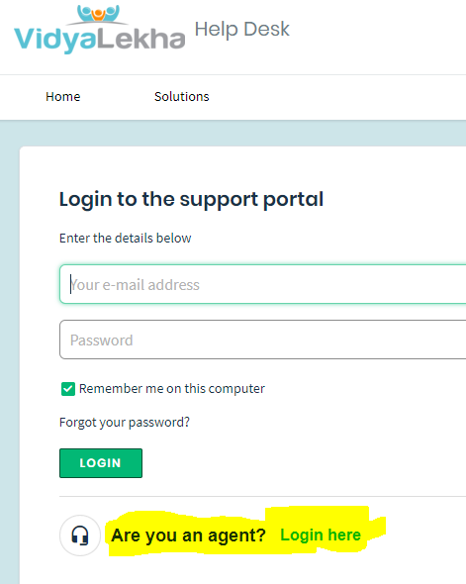

- App: Download Freshdesk app from playstore
https://play.google.com/store/apps/details?id=com.freshdesk.helpdesk&hl=en_IN
Login with your gmail id and password provided.

Ticket Creation process:
- Click on + Plus button in All tickets 2 Enter Ticket Information click Submit
Dashboard window. Click New Ticket
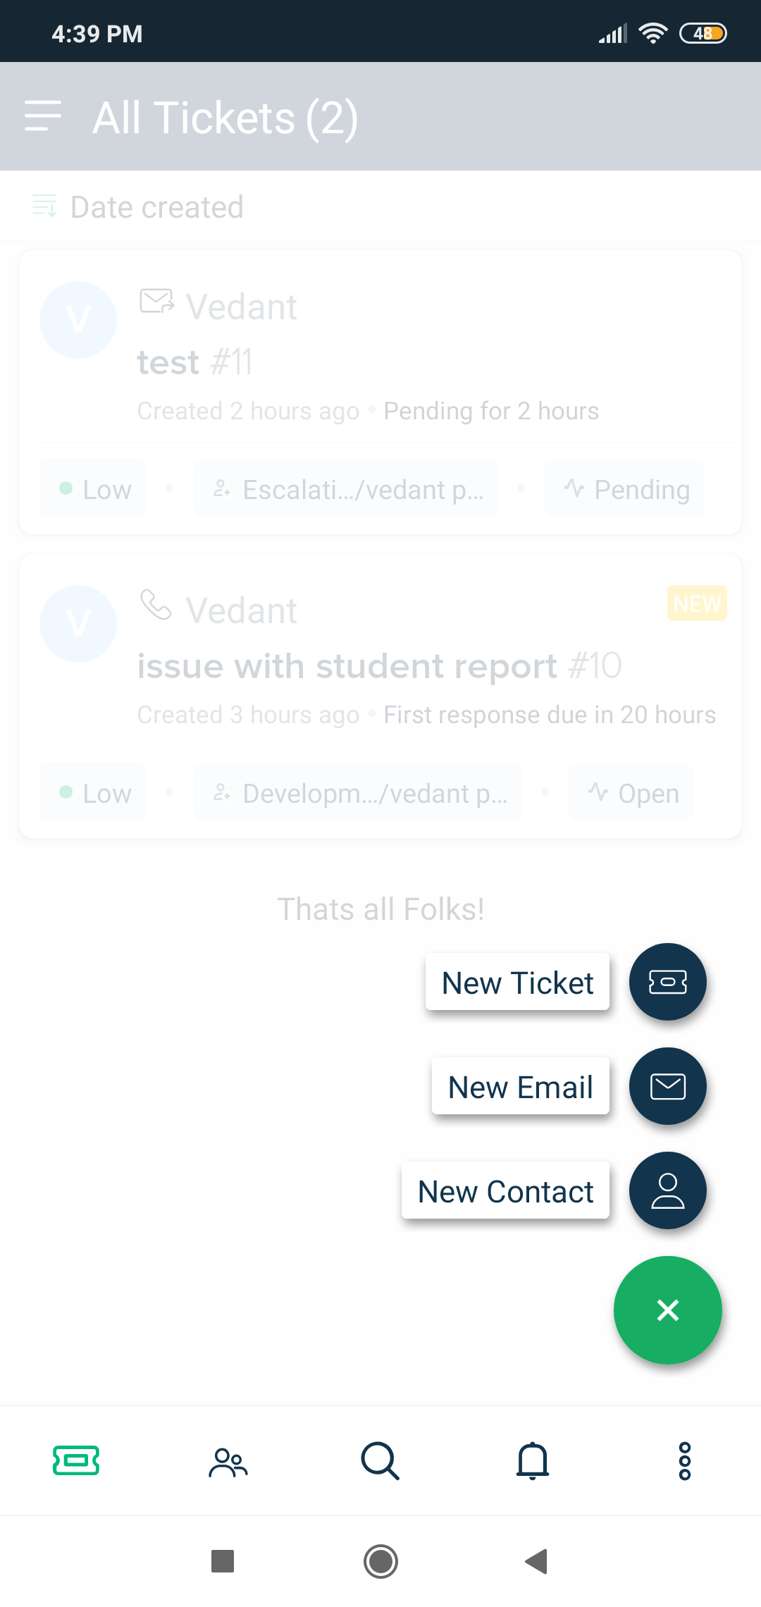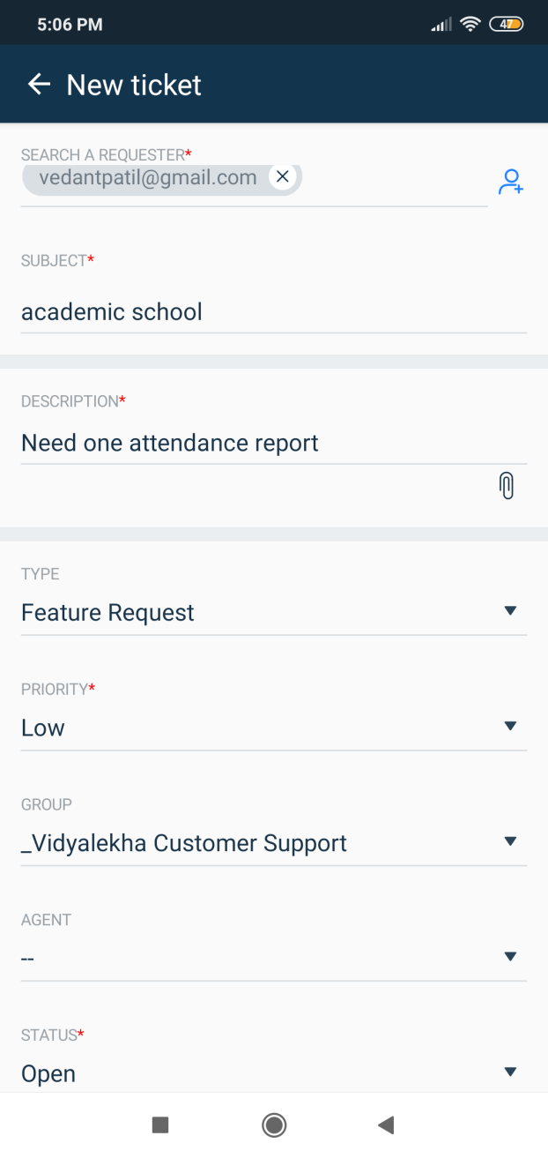

- Ticket will be added in the system you can check current status on dashboard.

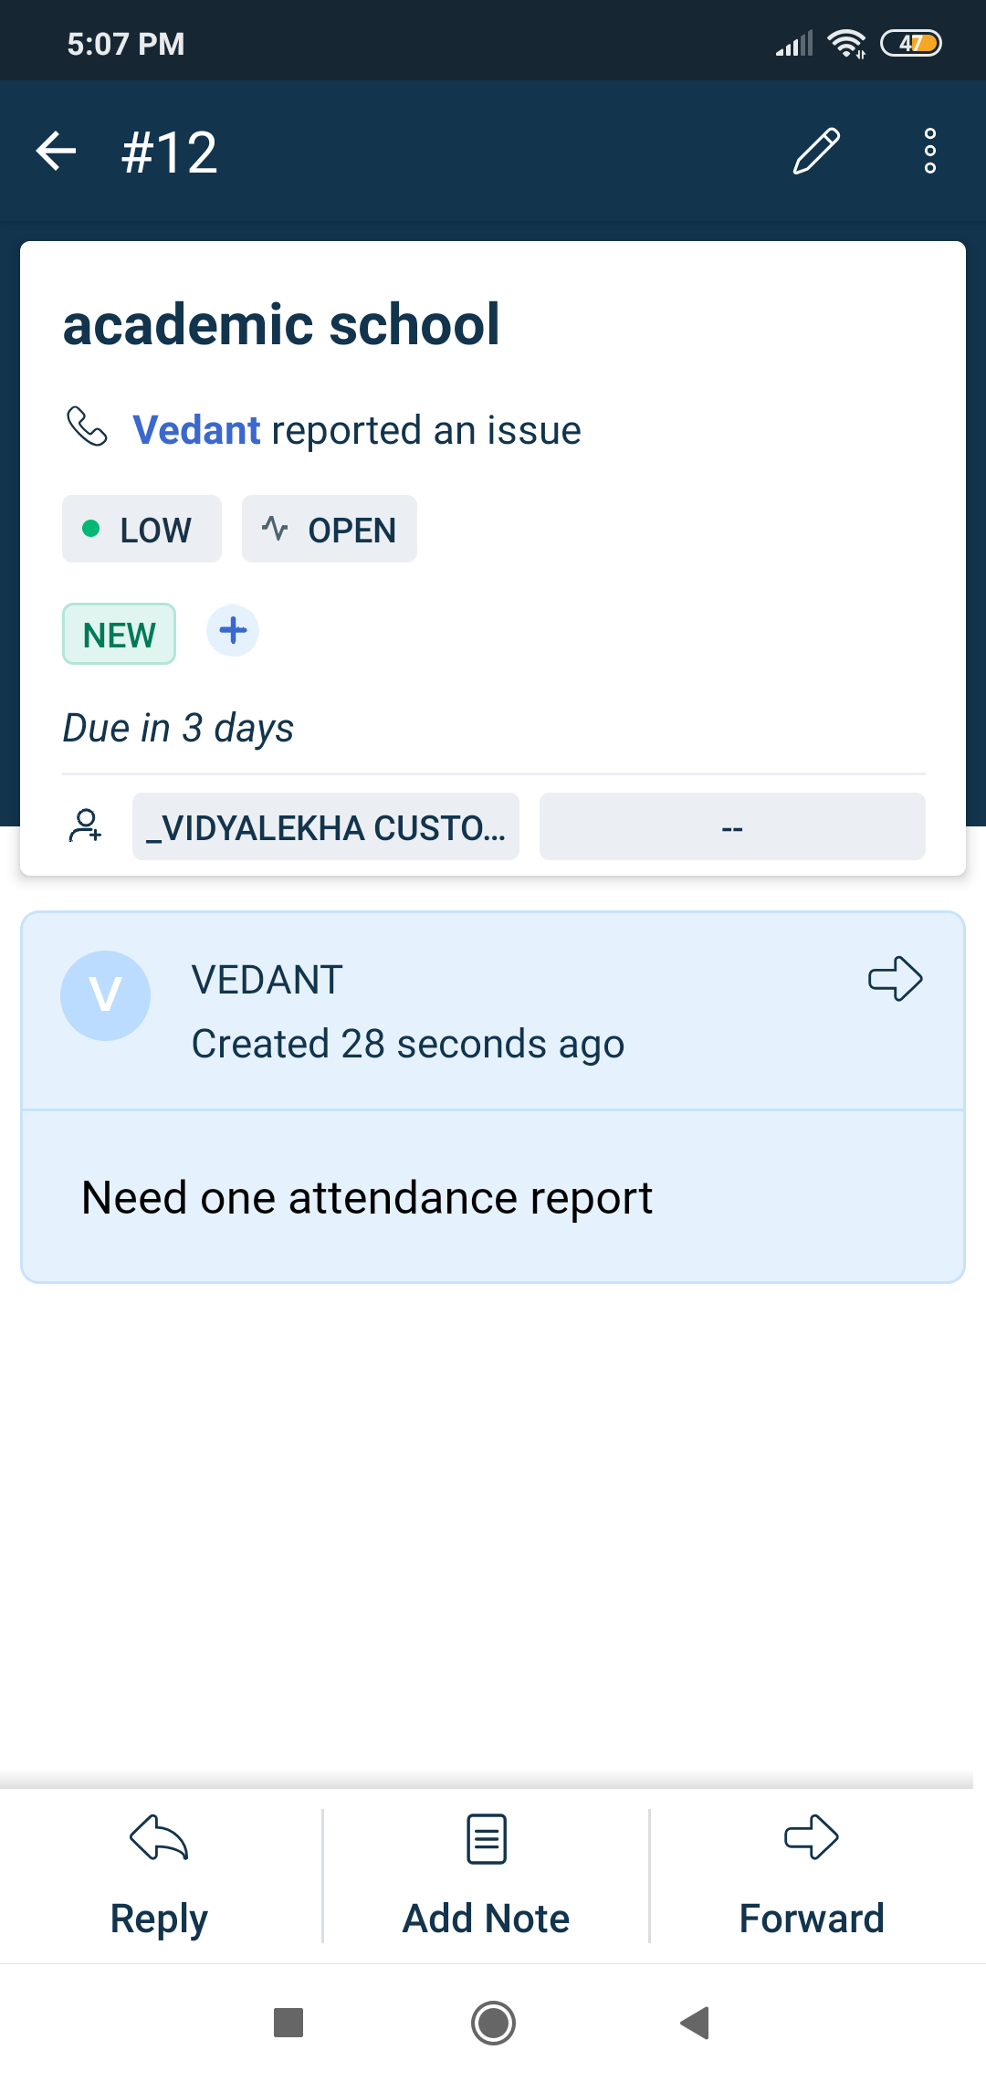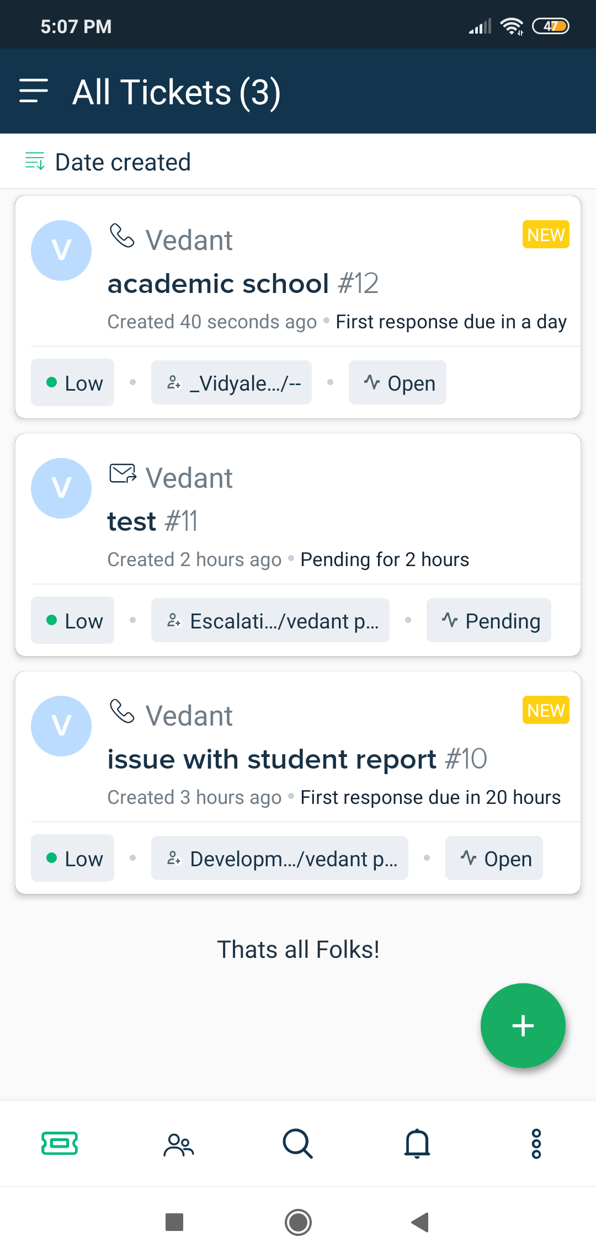

- Once Ticket is added to the system, Operation team will TAG ticket with the “School Name” and “Inst_ID” for further tracking.
- You can mark Ticket status as resolved once issue is fixed.

New Help Portal and Help Desk Chat
Operations team will have FreshChat app / Web open to support direct customers queries. Separate communication has been sent to all members with installation procedure.

