Virtual Classroom with Youtube Go Live streaming option

To deliver a Youtube online Go live Streaming session, you have to logged in as individual teachers google account. Because if you use school youtube channel account, you can deliver a single stream at a time.
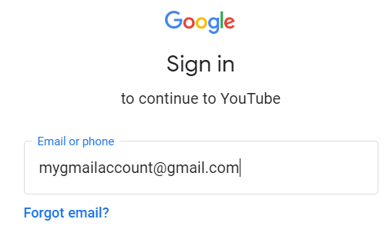
Click on Create a video icon
You will have two options first one is upload a pre recorded video or GO live option. Click on go live option
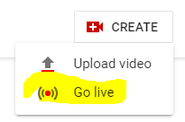
Fillip live stream info form
- Title – name of the live session
- Select as Unlisted (Do not use Public) Unlisted means it will be visible only to those who have url of the stream.
- Check the checkbox against Scheduled for later
Select Date and Time of the live lecture
- Click its made for kids
- Click next
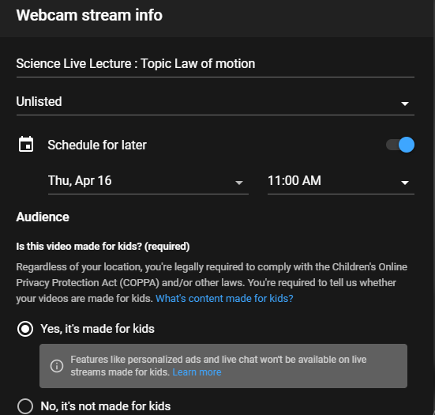
Upload Video thumbnail from computer or take live photo as thumbnail.
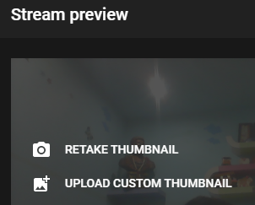
Click on SHARE button at the bottom of the preview windows

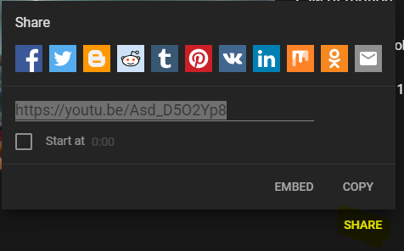

Click on copy link and click on DONE to save.
You can test if video stream is listed by copying the link and putting in chrome window

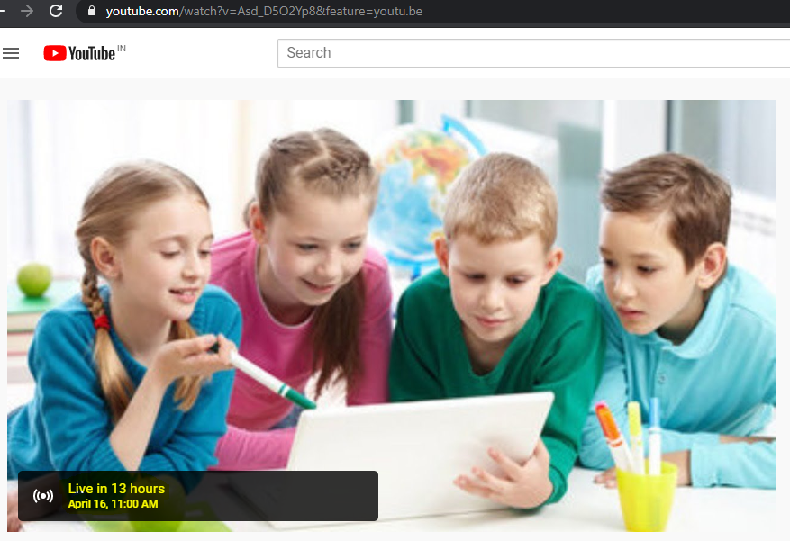
Copy this link in Virtual classroom post created for students
You can login back on scheduled time and start the streaming, which will be broadcasted to all students to whom link is shared

