Create Virtual Classroom using Zoom User Guide

What is Virtual Classroom?

Virtual classroom is changing the way teachers communicate to students with an easy, reliable cloud platform for video, audio and documents sharing.

In virtual classroom you can conduct live classroom sessions or post your study material with students or post pre-recorded your youtube video lectures.

Prerequisite:

All Teachers should create account on Free Zoom online video conferencing platform or any other platform supported by your organization.

Go to : https://www.zoom.us/
Click on Sign up, It’s Free button
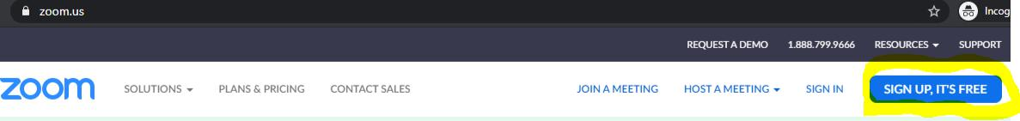

Signup with your email id or Sign up with Google account.
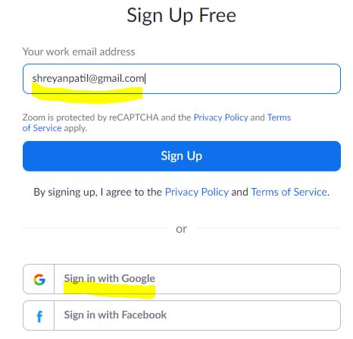

You will get verification link on email. Click on that and you will be logged in to account.

- “Virtual Classroom” widget on Portal dashboard:

On Portal dashboard there is one widget “Virtual Classroom”. Once you created the post that post will be visible on dashboard widget. At bottom of the widget you can see two buttons first is “Add Post” and second is “All Post”.

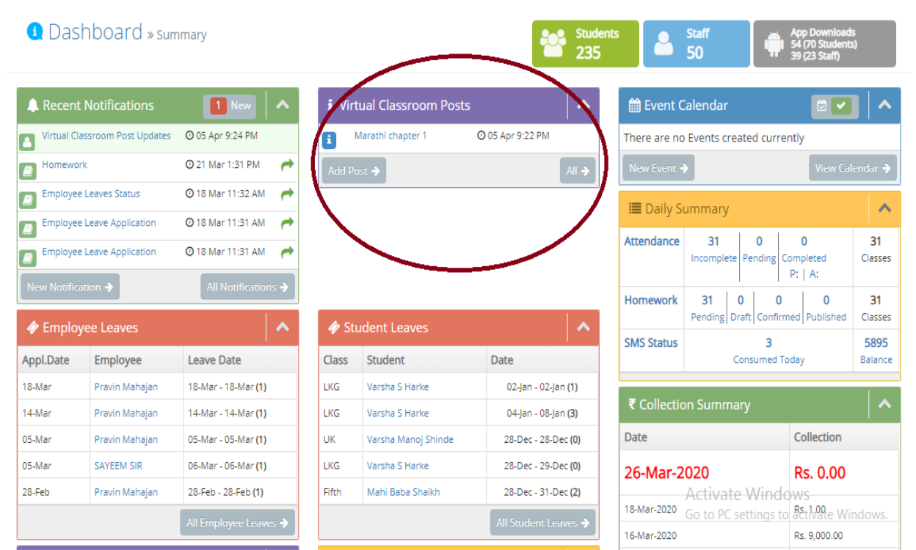

When you click on All Posts button, it will show you Virtual Classroom Timeline Page

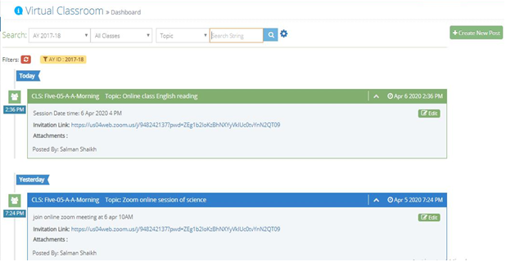

Staff APP Dashboard Widget
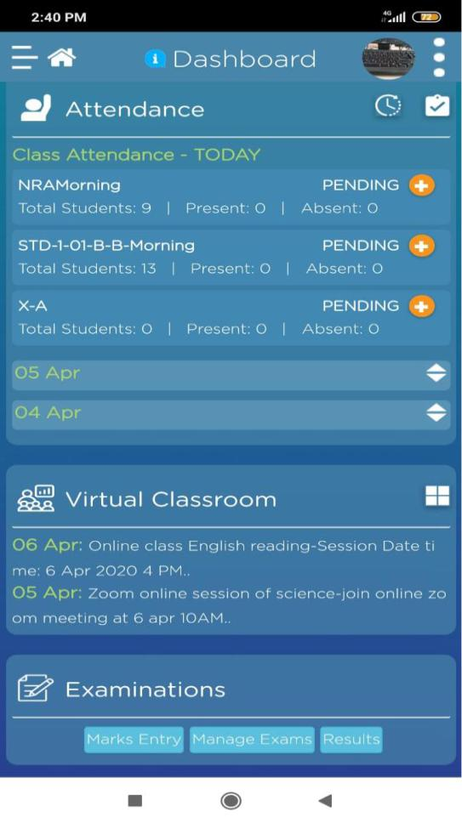

- Create new virtual Class

Before creating virtual class on Vidalekha, login to your Zoom account and schedule a video conferencing meeting as below
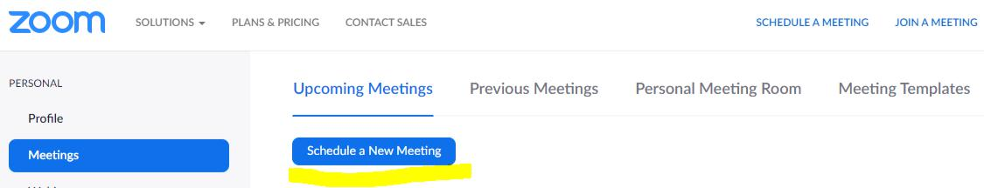

Fill up the meeting details as below. Keep other configuration as mentioned in below form. Keep video option off for the participant to avoid performance lag during meeting. Keep audio and computer audio (Teacher and students can communicate through laptop/mobile mic and speaker)
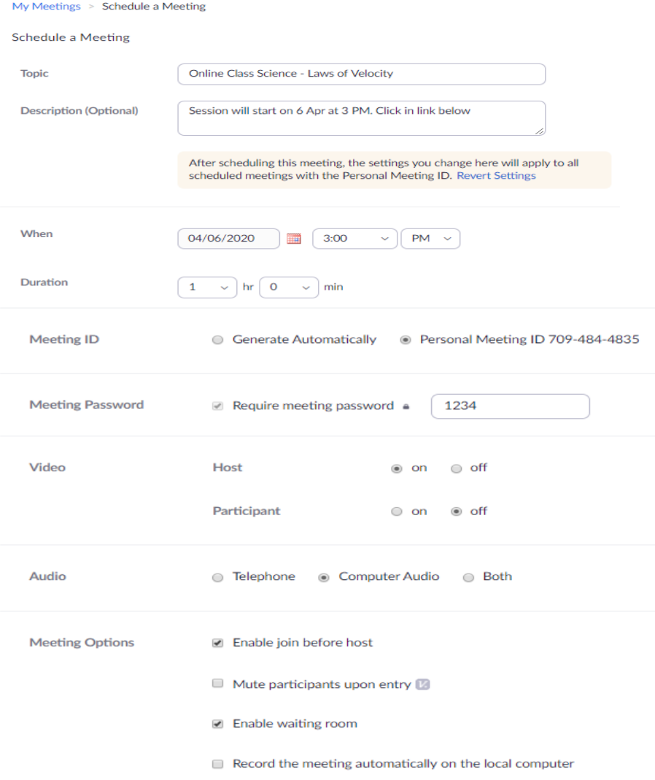

After saving copy invitation link
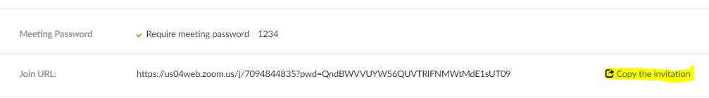

Go to Portal Virtual classroom new post page

1. Click on Create New post

- Fill up the information on the form. Select the target students (Standard or class) selection of subject is optional.

- Put the invitation message link in Link 1 box. If you don’t want to conduct online classroom and just want to share pre recorded youtube video, you can enter youtube URLS here.

- You can attach reference/presentation material

- Set notification option from the different options provided

- Save as draft or publish the post and submit the form
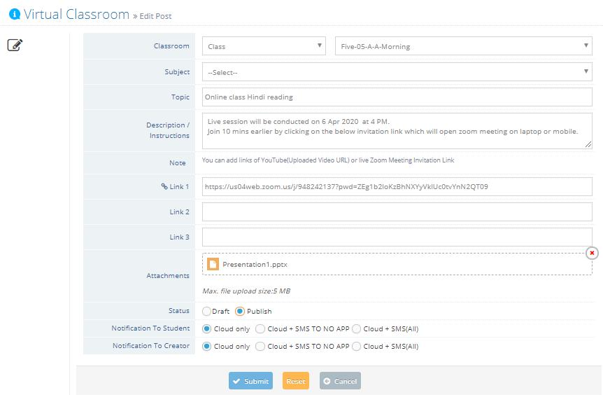

Classroom | Classroom is the target audience to whom you going to post
mandatory | Standard and class are two options. You can share post to particular
 | single standard or class
Subject | According to selected classroom respective subject list get display in
optional | subjects. If you post is regarding to any subject then select subject from
 | list
Topic | Name of study topic on which you are going to teach
mandatory
Description/ Instructions | Describe your study topic in details or you provide instructions if you are
mandatory | going to take any live online session like zoom/other video conferencing
 | tools.

Link 1/ Link 2/ Link 3 | You can add links of YouTube(Uploaded Video URL) or live Zoom Meeting
optional | Invitation Link
Attachments | You can share any study material document like
optional | text/word/ppt/excel/pdf/img files
Status | Draft and publish, To save post for further modification and share later,
mandatory | you can keep post in draft mode. Draft post only visible to post creator.
 | Once you publish post it will be visible to selected classroom
Notification to students | Here you can choose the option like though which channels (sms, web,
mandatory | email, app) you want to send notification to classroom
 | 1. Cloud Only: will send to web, email, app
 | 2. Cloud + SMS TO NO APP: will send to web, email, app and
 | SMS only to those users who don’t have app installed
 | 3. Cloud + SMS(All): will send to web, email, app and SMS
Notification to Creator | Notification to post author means who created the post
mandatory

Virtual Classroom TimeLine:

- Post visibility:

  - Admin can view all post

  - Teachers can view only posts created by him/her.

  - Students can view post only of their standard and class

- Search filter: Various search filters provide to search particular post.

- You can go to create new post by clicking on “Create New Post” button. “Create new post” allowed to only admin/teachers

- You can edit post if you want to update the post details.

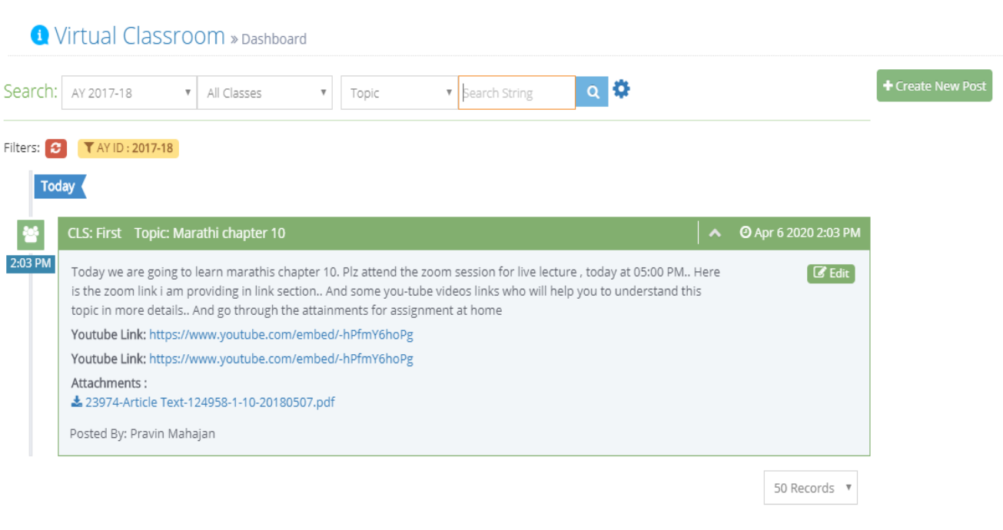

CONTACT YOUR RM FOR FURTHER SUPPORT

