YouTube Channel Creation & Video upload Guide
The document provide following information
- How to create YouTube channel and upload video in YouTube channel.
- How to get it video link and use it in Staff App in Virtual Classroom Post

- Open browser and enter urlhttps://www.youtube.com/ press Enter. In right corner of page shows the SIGN IN button.Click on that button.
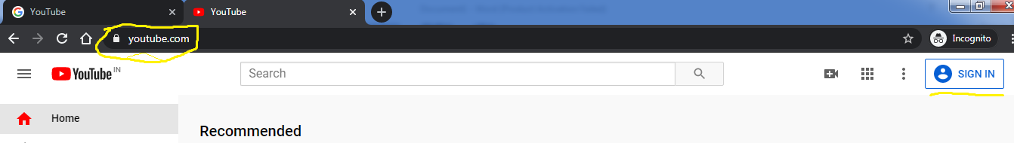

- In next window shows the sign in page .To create you tube channel require the Google account.
- If you have Google account then directly enter your email id then click next button and enter password and click next. Move to Step 4 directly
- If you does not have the account then click on Create account button
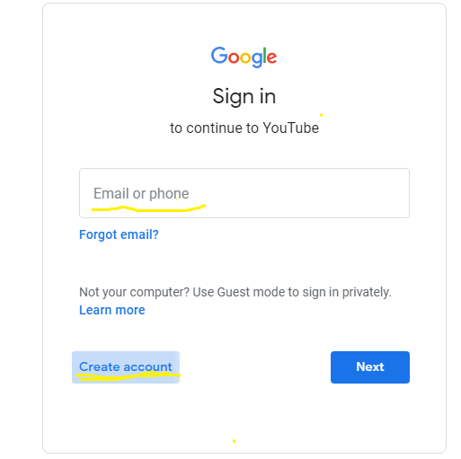

- If you does not have Google account then create it by filling all these information.
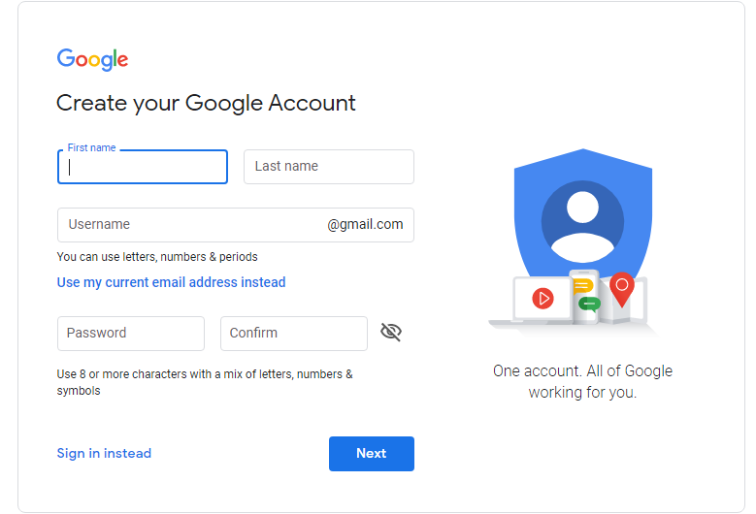

- After creating or sign in into your Google account. Enterurlhttps://www.youtube.com/in browser. Then top right corner of page see the Google account user profile icon click on that icon.
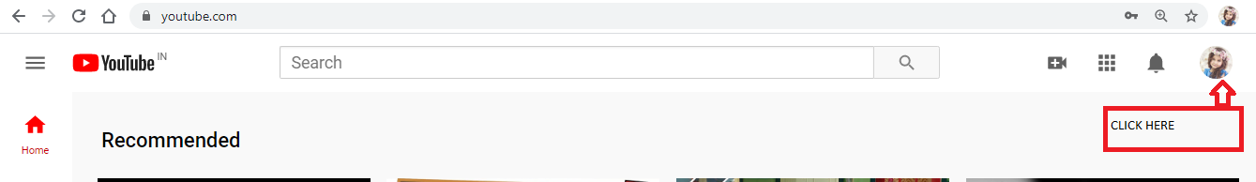

- Then pop up will shows then click on Create channel. If you already created channel then it will shows like Your Channel.

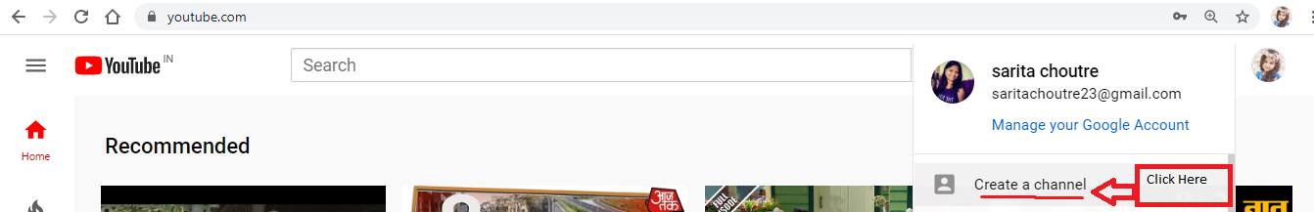

- Click on GET STARTED
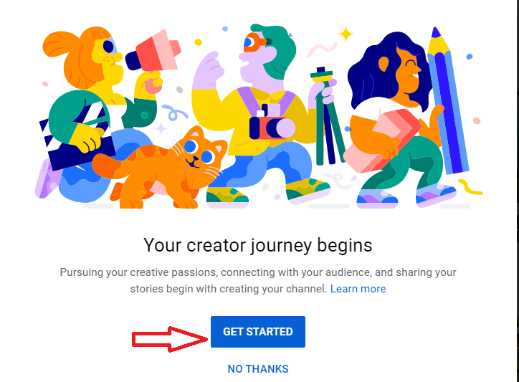

- To create channel require channel name. Select custom name then click on Select button.
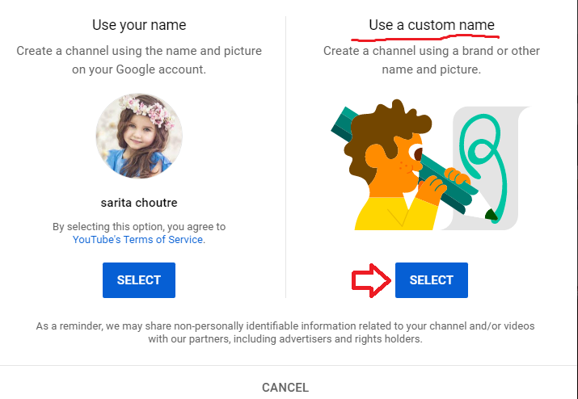
- Provide your school short name or any other Channel name, click on checkbox then CREATE button will enable.

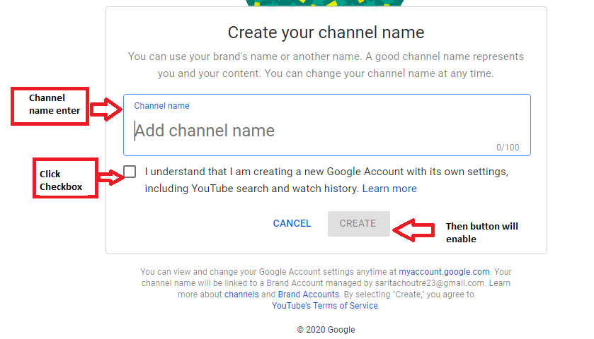

- After Clicking on CREATE button your YouTube channel will created. Then you can set profile picture.

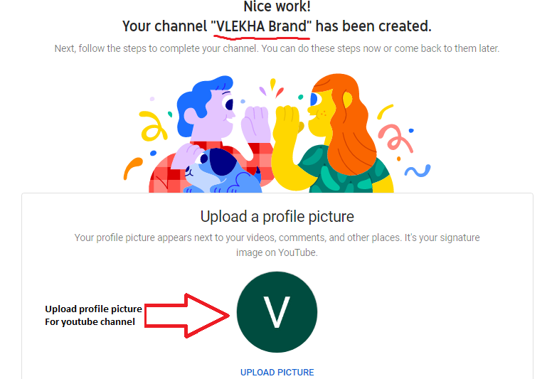

- When you scroll the page you seen this boxes. Add channel description. It’s not mandatory fields
- If you have extra links regarding your work then add it otherwise click on Save Up Later link.
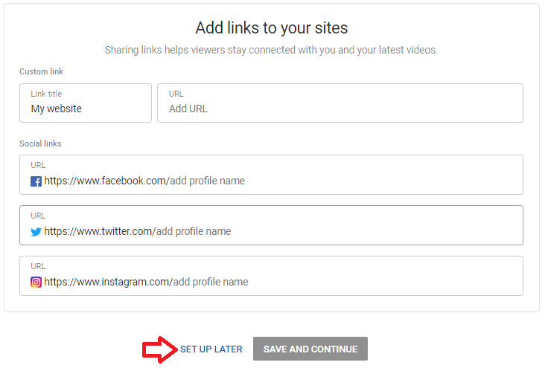
Uploading Videos to your Channel:
- Now finally you can see the YouTube channel page with channel name. Provided upload video button at the bottom. Using that you can upload video.
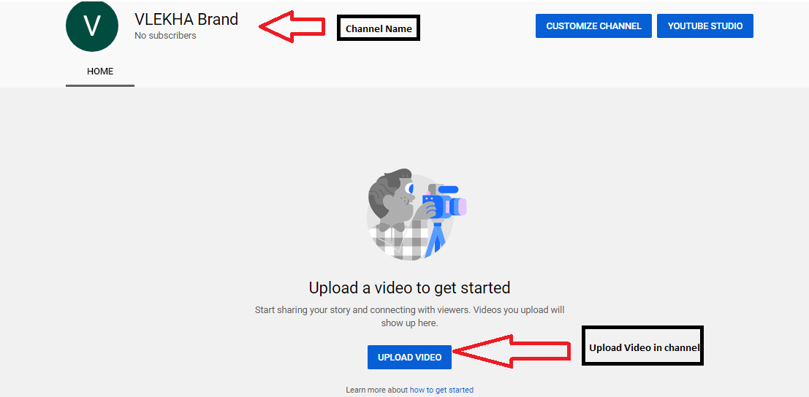

- You will see the pop up window on browser Click on Select Files to upload video.

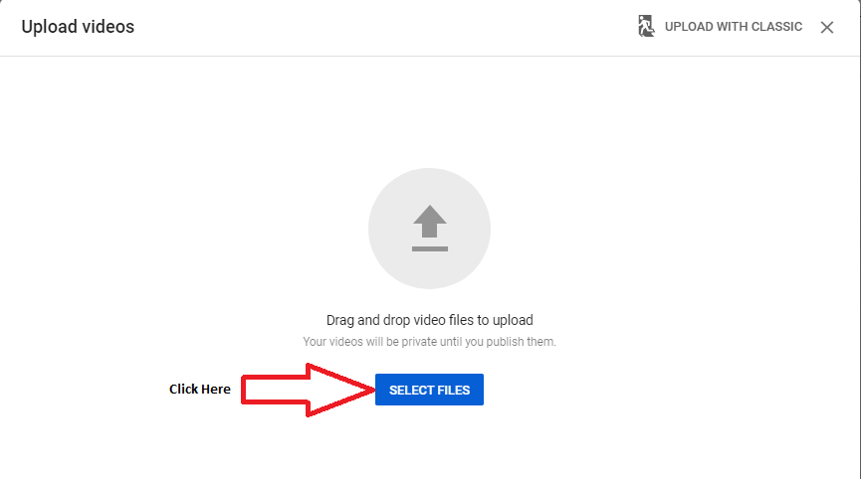

- After selecting video it will take folder name as video title click on next.
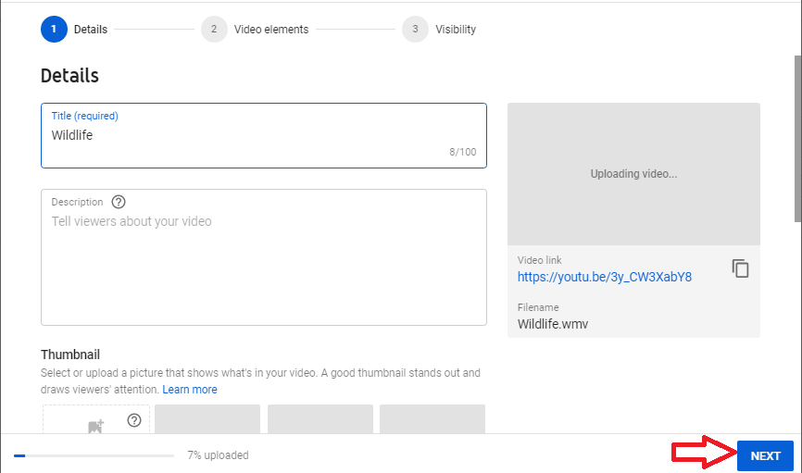

- Then it will ask age restriction select one radio button. Click NEXT.
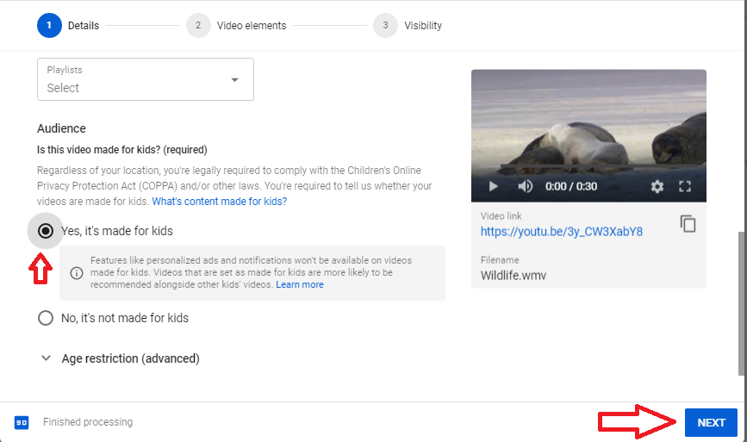

- Then it will ask for video visibility means video uploaded in channel can view other people or it put as private. Choose one option as suitable for you and click blue button at the right corner of page.
- Make video public (All can view this video)
- Put it as private (maintain video yourself only)
- Make unlisted
- Schedule (means give particular date and time so other people can access that video)
Select it as a Public so that everyone will be see the video with shared URL
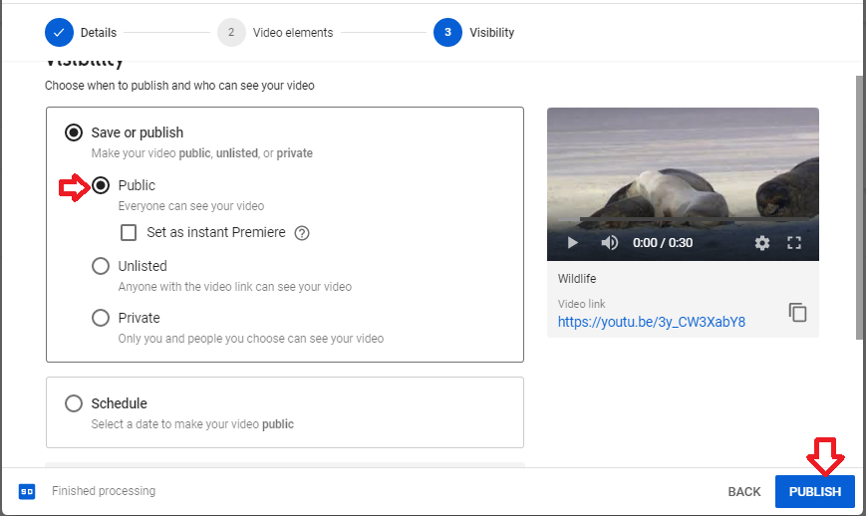

- Then Selected Video will be present on your YouTube channel. You can see you tube video link also at the bottom of video. Eg.https://youtu.be/3y_CW3XabY8
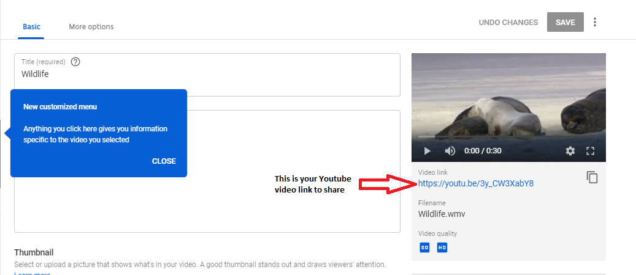

- Open this video in YouTube click on video which shows in left side of page
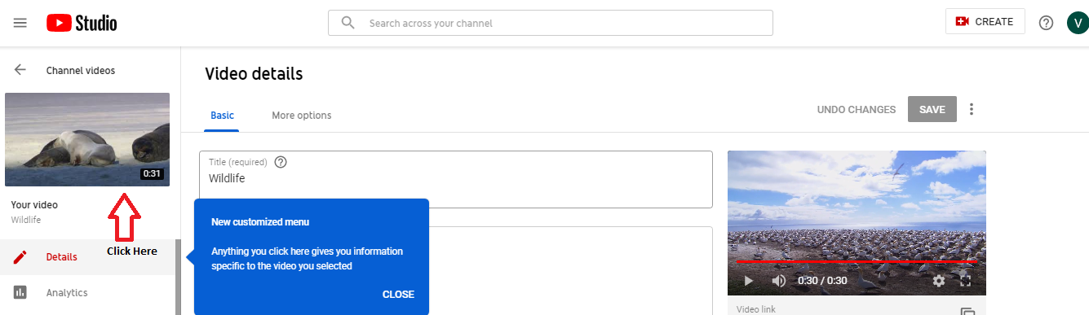

- Once video open in browser then you can get Video URL link as below
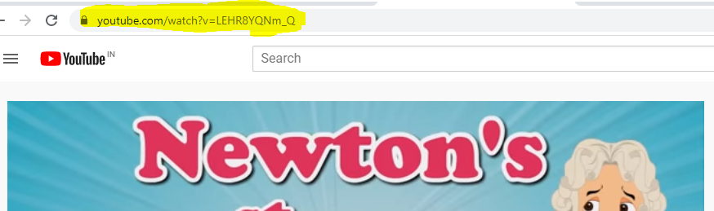
- You can copy this link and use it in Virtual Classroom Post.
Refer Virtual Classroom module for further information.
Create Virtual Classroom Post using Pre Recorded Youtube video URL
- Go to Portal Dashboard, You will find Virtual Classroom Widget. Click on Add post

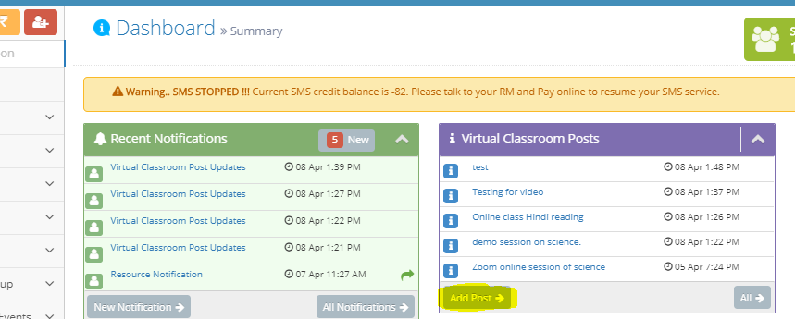
2 Fill up the post information.
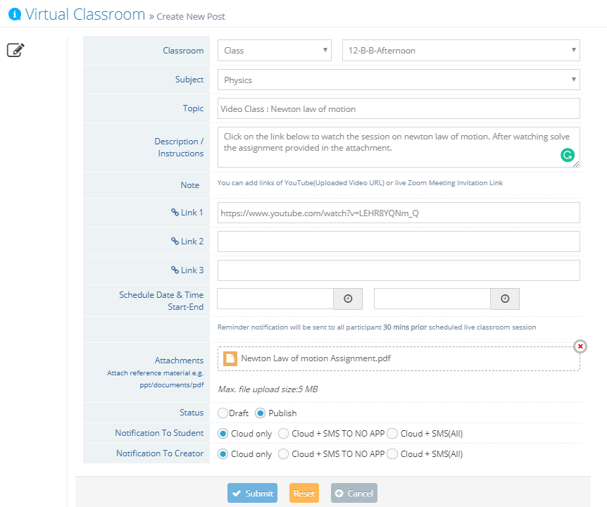
And click on Submit.
Your post will be crated and notification will be sent to selected class students.
Students will get Notifications on App/SMS/Web, post will be visible in the dashboard widget on Web and Parent App
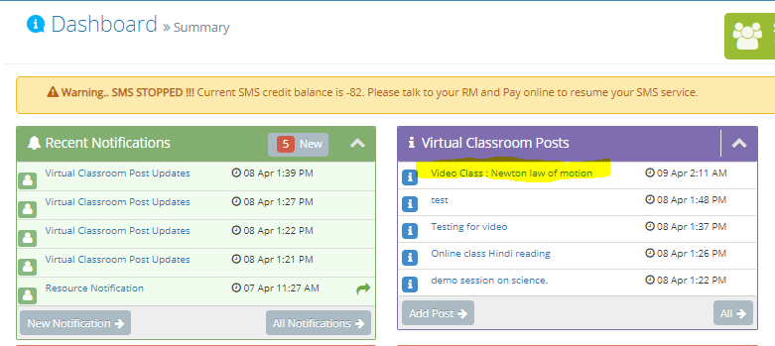

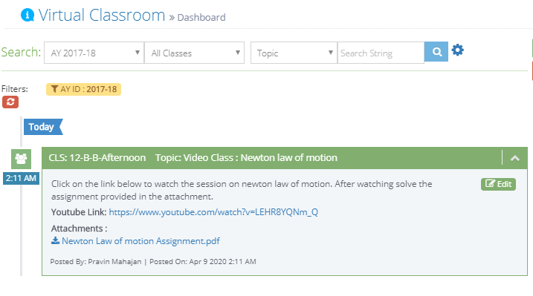
Students will click on the Youtube link and recorded video class will be played in new browser. They can download the reference material attached in the attachments section.

